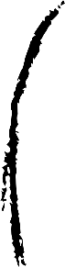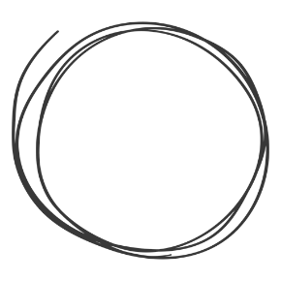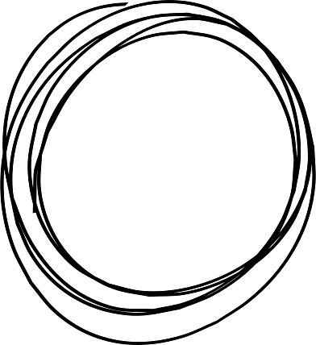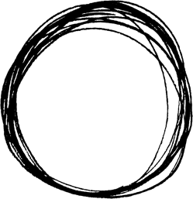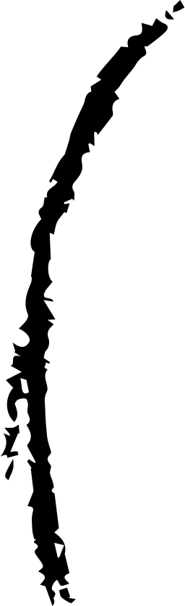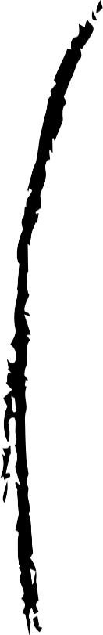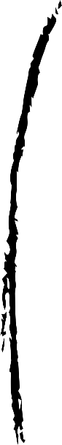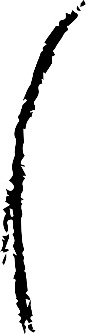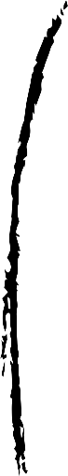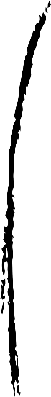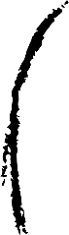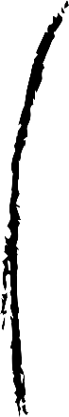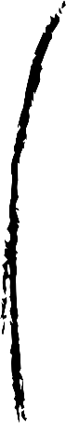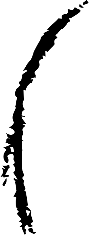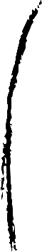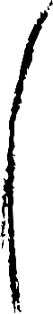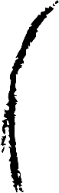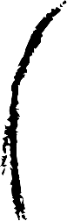

**CUSTOM MAP**

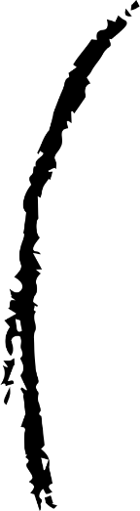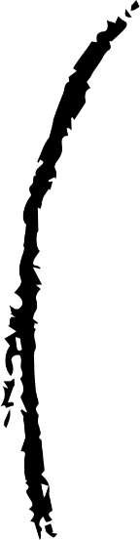



Contents

Blueprints 3

UML Diagram 4

Preface 5

I Targeted Implementation: Student Admission Scenario 7

II Optimizing Data Structures: An Integrated AVL Tree and Hash Table Implementation 9

II.i Table component 10

II.ii Tree component 13

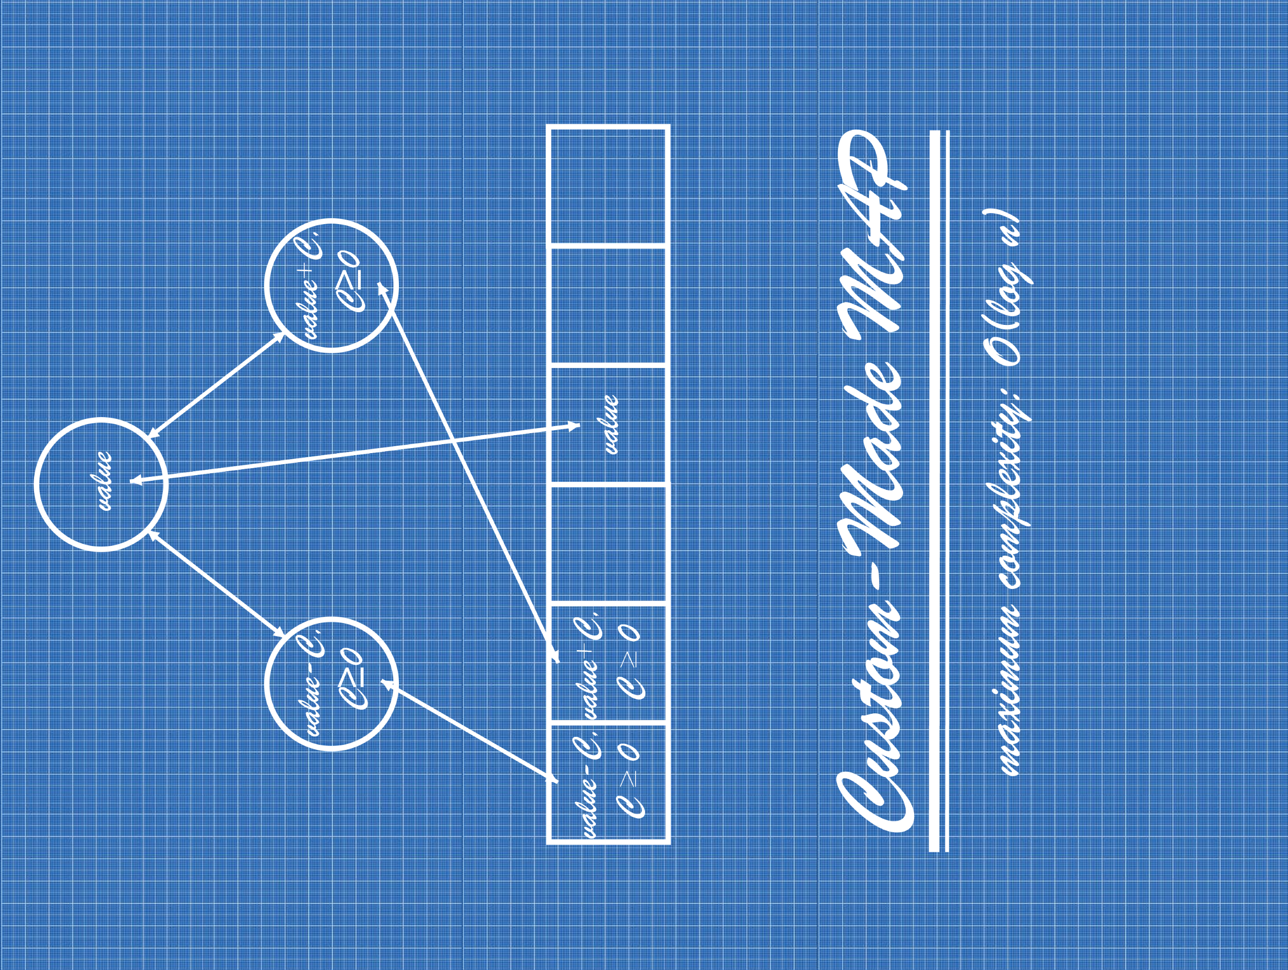

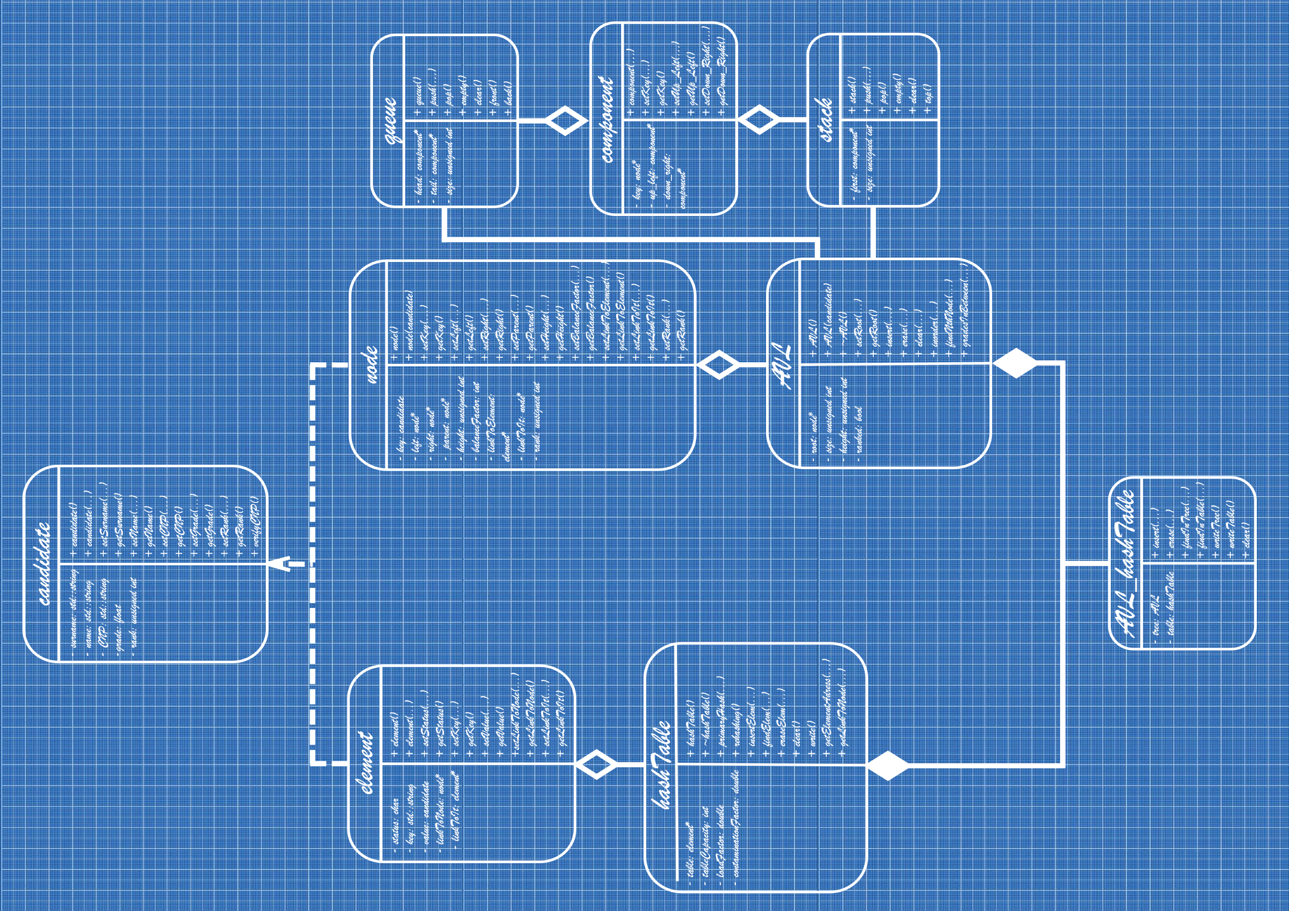

Preface

Steve Jobs once famously remarked, “You can’t connect the dots looking forward; you can only connect them looking backwards. So, you have to trust that the dots will somehow connect in your future.”

With this sentiment in mind, I embark on this project with the hope that it will mark the inception of a promising career. The path ahead may be challenging, but I am resolute in my commitment. I am fueled by a deep passion for what I do, a conviction that keeps me driven despite any obstacles.

The notion of loving one's work, as Jobs so eloquently put it, resonates deeply with me. Great work is a product of genuine affection for one's craft. This belief serves as a guiding principle, ensuring that my journey remains one of fulfillment rather than frustration.

This endeavor stands as a testament to the invaluable lessons from two pivotal subjects in my first year of university: Data Structures and Object-Oriented Programming. These foundational pillars have empowered me to navigate the intricacies of programming with confidence.

The genesis of this project lay in the implementation of an AVL tree, a pursuit that led me to explore avenues of enhanced efficiency. By amalgamating the concept of a hash table with the tree structure, I have achieved a level of complexity that stands among the finest in the realm of data structures.

In the realm of programming, innovation often emerges from the crossroads of necessity and ingenuity. This project embodies my determination to push those boundaries. With each line of code meticulously crafted, I strive not just for functional efficiency, but for elegance and creativity. While the road ahead might be uncharted and the challenges formidable, I am inspired by the words of Jobs to embrace uncertainty as a catalyst for growth. I have poured my energy into this project, envisioning it not as a mere culmination of technical skills, but as a testament to the spirit of exploration and the unwavering pursuit of excellence. As I stand at the precipice of what lies ahead, I am fueled by an unwavering belief that every line of code written today contributes to the story I will proudly share in the future.

Rusu Claudiu

August 2023

I Targeted Implementation: Student Admission Scenario

The implementation I have developed is designed to be versatile and capable of handling various data types, with minor adjustments required to the class structure for specific cases. However, the project is most optimized for the following scenario:

Consider a scenario where students from Romania are undergoing an admission exam for a university. Each student profile comprises the following attributes, presented in the order they are compared within the implementation:

I.i Grade

This attribute is of type float and ranges from a minimum of 0 to a maximum of 10.

I.ii Surname

The surname is the initial component of the full name, written according to Romanian conventions, and is represented by a single std::string.

I.iii Name

This attribute is of type std::string and consists of a single word representing the student's first name.

I.iv CNP (Personal Numeric Code)

The CNP is a 13-digit identification code specific to Romanian citizens. It encompasses various components related to the individual's birth date, gender, birth location, and random digits, with the final digit serving as a control element.

I.v Rank

Lastly, this attribute signifies the student's relative position compared to other students.

II Optimizing Data Structures: An Integrated AVL Tree and Hash Table Implementation

As the title of this documentation implies, the algorithm I've developed emulates the functionality of the map data structure found in the C++ STL library. However, my implementation takes a different approach. Instead of utilizing a Red-Black tree, I've used an AVL tree, which enforces stricter rules that lead to more efficient search operations.

My implementation is composed of two primary components: the table and the tree, intricately linked together to form a cohesive structure. The table draws inspiration from the concept of a hash table with open addressing. Its attributes are further enriched with additional properties, facilitating seamless connections to the second component, the tree.

For optimal collision management and efficient memory utilization, I meticulously selected the murmur3 hash function for the 32-bit architecture, ensuring minimal collisions and reasonable memory consumption – a perfect fit for this project.

The tree component, serving as an augmented data structure, finds its foundation in the AVL tree. This augmentation introduces two supplementary attributes that establish a connection with the first component, the table. Additionally, I've integrated extra functions within this structure to serve the specific needs of the scenario.

II.i Table component

The table component is primarily an open addressing hash table. It consists of two classes: element and hashTable, each with their own separate header and cpp files.

The element class is the augmented one from the table part and it comprises five components:

* status: a character type that can take values of 'o' for occupied, 'f' for free, and 'd' for deleted.
* key: a std::string type variable responsible for the hashing process.
* value: a candidate type that stores candidate data.
* linkToIt: an element* type that self-references and is used to link a tree node with an element from the table.
* linkToNode: a node* type that points to a tree node.

While a standard hash table does not require the two additional pointers, these supplementary pointers contribute to the desired efficiency.

An integral aspect of the table involves the load and contamination factors, which demand careful consideration when selecting their values. The efficiency of an open addressing hash table diminishes as these factors increase. In my implementation, the load factor cannot exceed 0.75, and the maximum contamination factor is 0.3. Beyond these thresholds, the rehashing function is called.

I consider the hash function to be one of the most crucial functions in this table component, as it significantly influences the overall efficiency of the table. In my project, this function is located within the hashTable class and is named primaryHash.

II.i.1 primaryHash function

The current hash function is based on the murmur3 hash function with the addition of the testRate variable because my table of choice has open addressing.

In this specific implementation, the hash function accepts two parameters: the key to be hashed (key) and the insertion process's test rate (testRate). However, it's important to note that this function is not the actual hash function; instead, it derives its result from the murmur3 function and incorporates the test rate of the insertion process. The returned value is a combination of these two inputs represented as an integer. The true hash function requires two parameters: a key(key) of type const void* and its length(len) of type size_t.

The complexity of hash functions is assumed to be constant, so O(1) and the memory usage should be low, but there is always another perspective.

II.i.2 another approach

The current approach has an assumed O(1) complexity, but in reality it isn’t always true. Another approach that works only for this case is to create a table that can store any CNP combination. The maximum value for the CNP is 9.999.999.999.999 and the minimum one can be 1.000.101.010.011. With this information a hash table that can store 8.999.898.989.989 elements can be created. The corresponding hash function will be: hash(key)=key - 1.000.101.010.011.

This hash function ensures a consistent O(1) time complexity for each operation. However, this advantage comes with a trade-off — it consumes a substantial amount of memory. Due to the significant memory overhead, I opted to implement the first approach. Nonetheless, I have detailed the second approach to introduce a perfect hash method that eliminates the need for collision handling.

II.ii Tree component

The tree component is fundamentally an AVL tree. The data structure consists of two classes: node and AVL, each with their own separate header and cpp files.

The node class is the augmented one from the tree part, comprising eight components:

* key: a candidate type that stores candidate data.
* left: a node* type that points to the left child of the current node.
* right: a node* type that points to the right child of the current node.
* parent: a node* type that points to the parent of the current node.
* height: an unsigned integer type that stores the height of the current node.
* balance factor: an integer type that retains the balance factor of the current node.
* linkToIt: a node* type that self-references and is used to link an element from the table with a node from the tree.
* linkToNode: an element* type that points to an element from the table.

A standard tree does not necessitate the presence of a balance factor or the inclusion of the two additional linking pointers. This is why I refer to this structure as an augmented data structure. While in a conventional AVL tree, the balance factor of each node is recalculated whenever required and the two extra linking pointers are absent, I have introduced these attributes to optimize the processes within the tree.

Amidst these enhancements, I intend to analyze the three key processes of the tree: insertion, deletion, and clearing.

II.ii.1 Insert function

The role of the insert function is inherently implied by its name - the seamless integration of a new node into the tree component. Specifically, the insertion function is characterized by two essential parameters: the key value to be inserted and a pointer to the corresponding element in the table. This pointer serves as the linchpin that establishes a vital connection between the two interconnected components.

At the forefront of the insertion process is the assurance of value uniqueness. This validation is achieved through a meticulous comparison between the node to be inserted and the existing nodes in the tree, starting from the root and progressing until a null pointer is encountered. If a matching value is detected within the tree, the algorithm halts. Conversely, if a null pointer is reached, the insertion is deemed feasible. Upon attributing the appropriate node attributes, the linkToElement attribute is assigned to point to the corresponding table element. Subsequently, with an increment in the tree's size, the height and balance factor of the node are recalibrated. Should the insertion disrupt the tree's balance, the recalibration process extends further.

The complexity of my insertion function aligns with a logarithmic time complexity, O(log n), akin to that of a traditional AVL tree.

II.ii.2 Erase function

The erase function plays a pivotal role in eliminating undesired elements from the tree. Within my implementation, while there are two insertion methods, only one holds relevance. What sets this deletion process apart is the intrinsic efficiency gained through the established pointers linking the table and the tree. Unlike conventional cases where deletion often necessitates traversing the entirety or a subset of the data structure, this linkage circumvents such a requirement. Consequently, the erase function only requires a single argument, a pointer to the node intended for removal(Node).

The core mechanics of the erase function mirror those found in a typical AVL tree deletion. The algorithm meticulously addresses the three distinct cases, adapting its approach as needed. In instances where the node slated for deletion happens to be the root, a seamless transition occurs as the successor seamlessly replaces the predecessor.

The unique advantage of this erase function lies in its constant time complexity, a departure from the standard AVL tree's deletion complexity. With a constant time complexity of O(1), this efficient operation reflects the collaborative power of the table-tree linkage.

II.ii.3 Height and Balance factor recalculation

An additional vital aspect warrants discussion, encompassing both the insertion and deletion processes. While these considerations pertain not to the functions themselves, but rather to two pivotal functions within the entire implementation: recalculateHeightAndBalanceFactorAtInsertion and recalculateHeightAndBalanceFactorAtErasion. These functions underpin the very essence of what sets an AVL tree apart, enabling it to transcend the efficacy of a standard binary search tree.

Of paramount importance, these non-recursive functions serve as the linchpin that defines the superior efficiency of the AVL tree. Uniquely, they operate from the point of insertion or erasure up to the root. Even in the most intricate scenarios, their operational scope remains contained, ensuring their influence remains localized. In the best-case scenarios, they merely adjust height and balance, yet even in more complex cases, their influence extends just as effectively.

It is my conviction that these functions stand as the differentiating factor, elevating the AVL tree above its counterparts. Their non-recursive nature and strategic operational scope symbolize the very essence of the AVL tree's superiority, making it a pinnacle choice among various tree structures.

II.ii.4 Clear function

The final function within the tree component that warrants discussion is the clear function. Operating as a postorder traversal of the tree, the clear function undertakes the responsibility of deleting each component. What distinguishes this traversal is its utilization of a custom-designed stack mechanism, effectively sidestepping the need for recursion and thereby optimizing memory usage.

One notable attribute of the clear function is its time complexity. As anticipated, it operates with a time complexity of O(n), aligning with expectations given its comprehensive clearing process.